Sample Paper – 2009
Class – XII
Subject – Mathematics (041)

Time: 3 Hours Max. Marks: 100

$$\text{GENERAL} \text{INSTRUCTIONS : }$$
$1\text{.}\text{ All questions are compulsory }$
$\begin{aligned}2\text{.}\text{ The question paper consists of 29 questions divided } \\ \text{ in to three Sections A, B and C}\text{.}\text{ Section A contains 10 questions } \\ \text{ of 1 mark each, section B is of 12 questions of 4 marks each } \\ \text{ and section C is of 7 questions of 6 marks each}\text{.}\end{aligned}$
$\begin{aligned}3\text{.}\text{ There is no overall choice }\text{.}\text{However, an internal choice } \\ \text{ has been provided in four questions of 4 mark each } \\ \text{ and two questions of six marks each}\text{.}\end{aligned}$
$\begin{aligned}4\text{.}\text{ Use of calculators is not permitted }\text{.}\text{How ever you may } \\ \text{ ask for Mathematical tables } \\ \end{aligned}$
1 | If x + y = k is normal to the curve y² = 12x, then k is equal to  (a) 3  (b) 9  (c) –9  (d) –3
2 | Maximum value of f(x) = sin x cos x is  (a)  (b) 0  (c)  (d) 1
3 | Let f (x) = 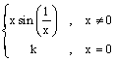and f is continuous at x = 0 ,then the value of k is  (a) k = 1  (b) k = 0  (c) k = 2  (d) k = 3
4 | If A is a square matrix of order n, then adj (adj A) is equal to  (a)  (b)  (c)
5 | If then find x
6 | The image of the interval [–1,3] under the mapping given by is  - [8,72]  (b) [-8,72]  (c) [0,8]  (d) [8,-72]
7 | If 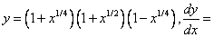  (a) 1  (b) –1  (c)  (d)
8 | Determine order and degree of differential equations: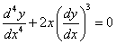
9 | Find the point of intersection of the line and the plane 3x-2y+z+5 = 0
10 | The mean and variance of a binomial distribution are 4 and 3 respectively, Find n?
 | SECTION-B
11 | Integrate 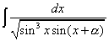
12 | If , for some prove that 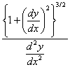is a constant, independent of and .  OR  If for , prove that 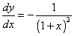
13 | If 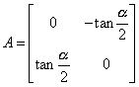and I is the identity matrix of order 2,  show that 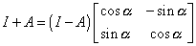
14 | Using properties of determinants, prove the following:  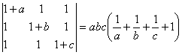  OR  Using properties of determinants, solve for x:  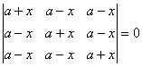
15 | Show that the Relation R in the set is an equivalence relation. where
16 | Prove that: 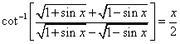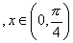
17 | If 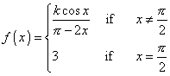find the value of if is continuous at 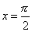.
18 | Solve the differential equation
19 | Solve 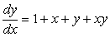  OR  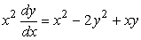
20 | . Find a unit vector perpendicular to each of the vectors $\vec{a}$ + $\vec{ b}$ and $\vec{a}$ - $\vec{ b}$ where  $\vec{a}$ = i + j + k , $\vec{ b}$ = i + 2 j + 3 k  OR  Show that the vectors 2 i – j + k , i– 3 j – 5 k and 3 i – 4 j – 4 k form the vertices of a right angled triangle.
21 | Find the image of the point P(1,2,3) in the plane
22 | A and B throw a dice alternatively till one of them gets a ‘6’ and wins the game. Find their respective probabilities of winning, if A starts first.  SECTION-C
23 | Using elementary transformations, find the inverse of the matrix $\left[\begin{matrix}1 & 3 & −2 \\ −3 & 0 & −5 \\ 2 & 5 & 0\end{matrix}\right]$  OR  If A=Find A⁻¹. Using A⁻¹, solve the following system of linear equations
24 | Bag I contains 3 red and 4 black balls while another Bag II contains 5 red and 6 black balls. One ball is drawn at random from one of the bags and it is found to be red. Find the probability that it was drawn from Bag II.
25 | A manufacturing company makes two models A and B of a product. Each piece of Model A requires 9 labour hours for fabricating and 1 labour hour for finishing. Each piece of Model B requires 12 labour hours for fabricating and 3 labour hours for finishing. For fabricating and finishing, the maximum labour hours available are 180 and 30 respectively. The company makes a profit of Rs 8000 on each piece of model A and Rs 12000 on each piece of Model B. How many pieces of Model A and Model B should be manufactured per week to realise a maximum profit? What is the maximum profit per week
26 | Find the area of the region bounded by the two parabolas y = x² and y² = x.:  OR  Find the area of the region bounded by the parabola y = x² and y = /x/ .
27 | Show that the maximum Volume of a cylinder which can be inscribed in a cone of height $h$and semi vertical angle $α$ is $\frac{4}{\text{27}}{πh}^{3}{\text{tan}}^{2}α$.
28 | Evaluate as limit of a sum: $\int_{1}^{3}{\left(2x^{2}+3x+5\right)}\text{dx}$
29 | Find the shortest distance between the lines  $\frac{x+1}{7}=\frac{y+1}{6}=\frac{z+1}{1}$ and $\frac{x−3}{1}=\frac{y−5}{−2}=\frac{z−7}{1}$

