Sample Paper – 2012
Class – XII
Subject –COMPUTER SCIENCE (Theory)

Time Allowed: 3hours Maximum Marks: 70
Note. (i) All questions are compulsory.
(ii) Programming Language: C+ +

Ques 1.
(a)What is the difference between Type Casting and Automatic Conversion? Give example in C++ to
illustrate both. 2
(b) Name the header files to execute the following function(s) in a program: 1
void main()
{
char Msg[ ]="Foreign Direct Investment";
for (int I=5;I<strlen(Msg);I++)
puts(Msg);
}
(c) Rewrite the following program after removing the syntactical error(s), if any. Underline each correction: 2
#include <iostream.h>
struct Pixels
{
int Color,Style;
}
void ShowPoint(Pixels P)
{
cout<<P.Color,P.Style<<endl;
}
void main()
{
Pixels Point1=(5,3);
ShowPoint(Point1);
Pixels Point2=Point1;
Color.Point1+=2;
ShowPoint(Point2);
}
(d) Find the output of the following program: 3
#include <iostream.h>
void Changethecontent(int Arr[ ], int Count)
{
for (int C=1;C<Count;C++)
Arr[C-1]+=Arr[C];
}
void main()
{
int A[]={3,4,5},B[]={10,20,30,40},C[]={900,1200};
Changethecontent(A,3);
Changethecontent(B,4);
Changethecontent(C,2);
for (int L=0;L<3;L++) cout<<A[L]<<'#';
cout<<endl;
for (L=0;L<4;L++) cout<<B[L] <<'#';
cout<<endl;
for (L=0;L<2;L++) cout<<C[L] <<'#';
}

(e) Find the output of the following program: 2
#include <iostream.h>
void Secret(char Str[ ])
{
for (int L=0;Str[L]!='\0';L++);
for (int C=0;C<L/2;C++)
if (Str[C]=='A' || Str[C]=='E')
Str[C]='#';
else
{
char Temp=Str[C];
Str[C]=Str[L-C-1];
Str[L-C-1]=Temp;
}
}
void main( )
{
char Message[ ]="SteveJobs";
Secret(Message);
cout<<Message<<endl;
}

(f) Study the following program and select the possible output from it with reason: 2
#include<iostream.h>
#include<stdlib.h>
#include<conio.h>
void main( )
{
clrscr( );
randomize( );
int Mynum,Max=4;
Mynum=20+random(Max);
for(int N=Mynum;N<=25;N++)
cout<<N<<"*";
}
- 20*21*22*23*24*25
- 22*23*24*25*
- 23*24*
- 21*22*23*24*25

Ques.2
(a) What is the difference and similarity between private and protected data members of a class? 2
(b) Answer the questions (i) and (ii) after going through the following program: 2
class Person
{
public:
char Name[20];
int ph_no;
Person(int x, char Xname[]) //Constructor 1
{
Ph_no=x;
strcpy(name,Xname);
}
Person(Person &t); //Constructor 2
};

i) Create an object such that it invokes Constructor 1?
ii) Write complete definition for Constructor 2.

(c) Define a class named STREAM in C++ with following description: 4
Private Members:
- AD_NO integer (Ranges 10-2000)
- Name String of 25 characters
- Percentage Float
- Fees Float
Public Members
- A function Read_Data to read object of STREAM type
- Function Display( ) to display the details of STREAM type..
- A function Select_Stud( ) to choose students for different streams depending on their percentage and display the fee they have to deposit.
Percentage | Stream | Fees
Percentage>=90 | Computer | 18000
Percentage<90 but >=80 | Biology | 14000
Percentage<80 but >=70 | Commerce | 12000

(d) Consider the following declarations and answer the questions given below: 4
class Nation
{
int H;
protected:
int S;
public:
void Input( ) ;
void Output( );
};
class World: private Nation
{
int T
protected:
int U;
public:
void Indata(int,int);
void Outdata( );
};

class State: public World
{
int M;
public:
void Display(void);
};
i) Name the base class and derived class of class World.
ii) Name the data member(s) that can be accessed from function Display().
iii) Name the member function(s), which can be accessed by objects of class World.
iv) What is the size of object of class State?

Ques 3.

(a) Write a function in C++, which accepts an integer array and its size as arguments and exchanges the values of the first half side with the second half side elements of the array. 3
Example: if an array of eight elements initially contains the elements as
2,4,1,6,7,9,23,10
Then the function should rearrange the array as
7,9,23,10,2,4,1,6
(b) An array S[40][30] is stored in the memory along the row with each of the element occupying 2 bytes, find out the memory location for the element S[20][10], if the Base Address of the array is 5000. 3

(c) Write a function in C++ to delete an element from a dynamically allocated Queue where each node contains a real number as data. 3
Assume the following definition of MYNODE for the same.
struct MYNODE
{
float NUM;
MYNODE = *Link;
} ;
(d) Write a function SWAPARR() in C++, to swap (interchange) the first row elements with the last row elements, for a 2D array of integers passed as argument of the function. 3
Example: if the two dimensional array contains

5 | 6 | 3 | 2
1 | 2 | 4 | 9
2 | 5 | 8 | 1
9 | 7 | 5 | 8
After swapping of the content of first row and last row, it should be as follows:

9 | 7 | 5 | 8
1 | 2 | 4 | 9
2 | 5 | 8 | 1
5 | 6 | 3 | 2

(e) Evaluate the following postfix notation of expression. Show contents of stack after every step. 2
True, False, AND, True, True, NOT, OR, AND
Ques. 4
(a) Observe the program segment given below carefully and answer the question that follows: 1

class Team
{
long TId;
char TName[20];
float points;
public:
void Accept( );
void Show( );
void PointChange( );
long R_TId( ) {return TId;}
};
void ReplacePoints(long Id)
{
fstream File;
File.open (”Team.Dat”,ios::binary|ios::in|ios::out);
Team T;
int Record=0, found=0;
while(!found && File.read((char*)&T, sizeof(T)))
{
if (Id==T.R_TId( ))
{
cout<<”Enter New Points”;
T.PointChange ();
_________________ //Statement 1
_________________ // Statement 2
Found=1;
}
Record++;
}
if(Found==1)
cout<<”Record Updated”;
File.close( );
}
Write the statement 1 to position the File Pointer at the beginning of the Record for which the Team’s ID matches with the argument passed, and Statement 2 to write the updated record at the Position.

(b) Write a function in C++ to print the count of the word he and she (ignoring the case) as an independent word in a text file STORY.TXT. 2

(c) Write a function in C++ to search for a BookNo from a binary file "BOOK.DAT", assuming the binary file is containing the objects of the following class. 3
class Book
{
int Bno;
char Title[20];
public:
int RBno()
{
return Bno;
}

void Enter()
{
cin>>Bno;gets(Title);
}
void Display(){
cout<<Bno<<Title<<endl;
}
};

Ques.5
(a) What do you understand by Union and Cartesian Product operation in relational algebra? 2

(b) Consider the following tables GAMES and PLAYER and answer (b) and (c) parts of this question:

Table: GAMES
GCode | GameName | Type | Number | PrizeMoney | ScheduleDate
101 | Carom Board | Indoor | 2 | 5000 | 23-Jan-2004
102 | Badminton | Outdoor | 2 | 12000 | 12-Dec-2003
103 | Table Tennis | Indoor | 4 | 8000 | 14-Feb-2004
105 | Chess | Indoor | 2 | 9000 | 01-Jan-2004
108 | Lawn Tennis | Outdoor | 4 | 25000 | 19-Mar-2004
Table: PLAYER
PCode | Name | GCode
1 | Nabi Ahmad | 101
2 | Ravi Sahai | 108
3 | Jatin | 101
4 | Nazneen | 103
(b) Write SQL commands for the flowing statements: 4
(i) To display the name of all GAMES with their GCodes
(ii) To display details of those GAMES which are having PrizeMoney more than 7000.
(iii) To display the content of the GAMES table in ascending order of Schedule Date.
(iv) To display sum of PrizeMoney for each Type of GAMES
(c) Give the output of the following SQL queries: 2
(i) SELECT COUNT(DISTINCT Number) FROM GAMES;
(ii) SELECT MAX(ScheduleDate), MIN(ScheduleDate) FROM GAMES;
(iii) SELECT Name, GameName FROM GAMES G, PLAYER P WHERE G.GCode=P.GCode
AND G.PrizeMoney>10000;
(iv) SELECT DISTINCT GCode FROM PLAYER;

Ques 6.
(a) State and verify Absorption Laws using truth tale. 2
(b) Write the equivalent Boolean Expression for the following Logic Circuit 1
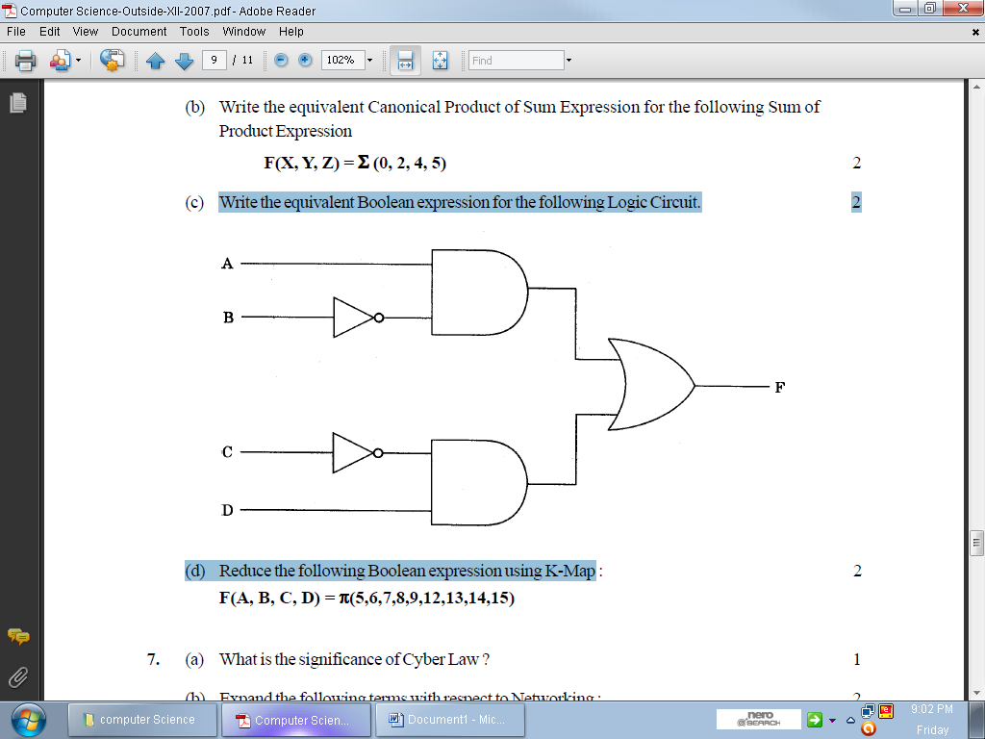

(c) Write the SOP form of a Boolean function G, which is represented in a truth table as follows: 1
U | V | W | G
0 | 0 | 0 | 1
0 | 0 | 1 | 1
0 | 1 | 0 | 0
0 | 1 | 1 | 0
1 | 0 | 0 | 1
1 | 0 | 1 | 1
1 | 1 | 0 | 0
1 | 1 | 1 | 1

(d) Reduce the following Boolean Expression using K-Map: 3
F(U,V,W,Z)= ∑(0,1,4,5,6,7,11,12,13,14,15) 1
(e) Give the dual of (A+BC+AB)

Ques 7
(a) Define the term Bandwidth. Give any one unit of Bandwidth. 1
(b) When do you prefer XML over HTML and why? 1
(c) Which of the following will come under Cyber Crime? 1
i) Theft of a brand new sealed pack Laptop.
ii) Access to a bank account for getting unauthorized mony transaction.
iii) Modification in a company data with unauthorized access.
iv) Photocopying a printed report.
(d) What do you mean by VoIP Address? 1

(e) Ravya Industries has set up its new center at Kaka Nagar for its office and web based activities. The company compound has 4 buildings as shown in the diagram below: 4

Raj Building

Fazz
Building

Harsh
Building

Jazz
Building

Center to center distances between various blocks
Harsh Building to Raj Building | 50 m
Raz Building to Fazz Building | 60 m
Fazz Building to Jazz Building | 25 m
Jazz Building to Harsh Building | 170 m
Harsh Building to Fazz Building | 125 m
Raj Building to Jazz Building | 90 m

Number of Computers
Harsh Building | 25
Raj Building | 50
Fazz Building | 125
Jazz Bulding | 10

e1) Suggest a cable layout of connections between the buildings.
e2) Suggest the most suitable place (i.e. building) to house the server of this organisation with a suitable
reason.
e3) Suggest the placement of the following devices with justification:
- Internet Connecting Device/Modem
- Switch
e4) The organisation is planning to link its sale counter situated in various parts of the same city, which
type of network out of LAN, MAN or WAN will be formed? Justify your answer.

(f) What is the mission of W3C? 1
(g) Write any one advantage of Open Source Software and Proprietary Software.

Paper Submitted By:

Name : Sunil Kumar
Email : mr_parmarsunil@yahoo.com
Phone No. 9812100604

