Guess Paper – 2013
Class – XII
Subject (INFORMATICS PRACTICES)

TIME : 3 Hrs. |  | M.M. : 70
General instructions :
- All questions are compulsory.
- This Question paper is divided into 3 Sections
- Section –A consists of 30 marks
- Section -B and Section –C are of 20 marks each.
- Answer the questions after carefully reading the text.

SECTION-A

Q1. (a) Which Topology provides each devices with a point to point connection to
every other device in the network. 1
(b) Which is the most commonly used protocol on Internet that ensures end –to
–end communication. 1
(c) Expand the following: (i) GNU (ii) FSF 1
(d) Which device links two similar types of networks? 1
(e) What is a Server? What are its types? 2
(f)Give two advantages of open standards. 2
(g) Give two advantages of tree Topology 2
Q2.(a)What is the difference between a Text field and a Text area? 1
(b)What is the purpose of return statement in a method? 1
(c) Which tag is used to specify: 1
(i)Table Data (ii)Table Row
(d)Write two attributes of <BODY >Tag 1
(e) What will be the value of Y if the value of X is given 21 2
(i)Y= ++ X; (ii) Y= X++;
(f) Write a function in java that accepts three different numbers as parameters
and returns the largest numbers 2
(g)Write two features of XML 2

Q3.(a) If a database “Library” exists, which Mysql command helps you to start
working in that database. 1
(b)Which clause is used to restrict the results on group? 1
(c)Priyanka, the teacher of Meerut International School, created a table
‘Class’.Marks is a column of this table. To find that whose marks have not
been entered she wrote the following query.
Select * from class where Marks =Null;
Help priyanka to run the query by removing the errors and rewriting it. 1
(d) A table “Emp”has one of its column named Salary.Give th
Command in Mysql to increase the employees by 10% 1
(e)Define the following : 2
(i) Foreign key (ii)Alternate Key
(f) Write any two features of Mysql 2
(g)The salary column of Emp table is given below:

Salary
2000
NULL
3000
2500
NULL

Based on this information, write the commands to do the followings:
- Increase the salary by 7% whose salary is NOT NULL 1
- Set the salary as 150 whose Salary IS NULL 1
SECTION-B
Q4 (a) What is abstract class? 1
(b) What do you mean by explicit type conversion? 1
(c ) What will be the contents of jTextArea1 after executing the following statement 1
jTextArea1.settext(“class XII\n Informatics\t practices”);

(d) Rewrite the following program code using do…while loop 2
int a, sum =0;
for (a=1; a< =50 ; a= a+2)
{
Sum = sum +a;
}
(e) The following code has some error(s).Rewrite the correct code underlining all the correction made: 2
Int I , sum = 0;
while ( I <= 20
{
Sum += i
i += 2;
}
jTextField1.getText ( “ “ +sum);
(f) What will be the contents of jTextField1 and jTextField2 after executing the following
Code 2
String str = “java GUI Programming”;
jTextFiled1.setText(str.tolowercase( ));
jTextField2.setText(str. Substring(5,8));
(g) Axis bank wants to calculate the compound interest of his clients. He ask software programmer to design an interest calculator. Rate of Interest will be calculate according to following criteria:
Time Rate of Interest
2 Years 7%
3 Years 8%
5 Years 10%
and to calculate the interest amount is P*(1+R/100) ☹T
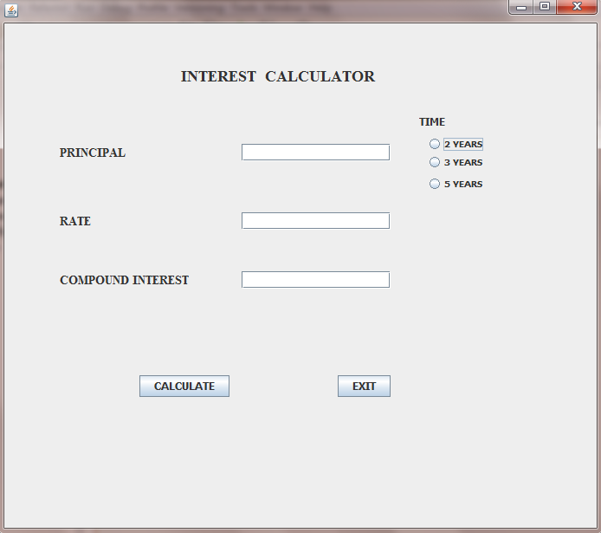
(a)Write the code to make the textfields for rate and compound interest uneditable 1
(b) Write the code to do the following:
(i)When calculate button is clicked the rate of interest and interest amount should be calculated as per above criteria and displayed in the respective text fields. 4
(ii) Close the application when Exit Button is clicked. 1
(You can assume any suitable names for various control on the form)
Q5. (a) What is the difference between a tuple and an attribute. 2
(b) Write the output of the following SQL queries: 2
(i)SELECT POWER(5,3);
(ii)SELECT SUBSTR(‘Barak Obama’,2,3);
(iii)SELECT TRUNCATE (292.672,1);
(iv)SELECT CHAR(65,66,67);

(c) Consider the table CRICKET given below .Write the commands in SQL for (i) to (iv) and output for (v) to (viii).
TABLE CRICKET
S.NO | PLAYER | AGE | CITY | RUNS | WICKETS
1 | Sachin Tendulkar | 39 | Mumbai | 15216 | 105
2 | Virender Sehwag | 37 | Delhi | 6244 | 82
3 | M.S.Dhoni | 32 | Rachi | 5219
4 | Rahul Dravid | 37 | Banglore | 9325 | 11
5 | Yuvraj Singh | 32 | Mumbai | 8244 | 126
- To display all the information about the players who lived in Mumbai city
- To display Players name, age and runs who have scored more then 8000 runs
- To display Player name and city of those players who have not taken any wickets
- To count the numbers of players of each city
- Select Min(age) from Cricket;
- Select Max(runs )from cricket;
- Select Count( Distinct (city)) from cricket;
- Select Avg(Wickets) from cricket;
SECTION-C
Q6 (a) Write a SQL command to create the table ‘Passenger’ with the following structure 2
TABLE :PASSENGER
Field Name | Filed Type | Constraint
P_no | Varchar(8) | Primary Key
P_name | Varchar(25) | Not Null
Train _No | Integer(5)
Age | Integer(3)
Class | Varchar(8)
Fare | Integer(4)
(b)In the database ,there are two tables, “Customer” and “Bill” as shown below: 2
CUSTOMER
CUST_ID | C_NAME | CITY | PHONE
1 | Ayush | Panipat | 9812015367
2 | Sanjay | Rohtak | 9466623546
3 | Rajeev | Sonepat | 9616254447
BILL
Bill_No | Bill_Dt | Cust_Id | Bill_Amt
1 | 2010.11.05 | 2 | 2400
2 | 2010.08.10 | 1 | 1200
3 | 2010.09.07 | 3 | 1500
4 | 2010.12.23 | 1 | 1800
5 | 2010.10.17 | 2 | 2000
- How many rows and columns will be there in the Cartesian product product of these two tables.
- Identify the foreign key column in the table bill

(c) Consider the tables Student and House given below:
HOUSE

H_CODE | HOUSE_NAME
H1 | VIRJANAND
H2 | SHARDHANANAD
H3 | DAYANAND

STUDENT

ADM_NO | NAME | CLASS | H_CODE
1001 | ANKITA | VII | H2
1002 | RAHUL | IX | H1
1003 | SAHIL | VII | H1
1004 | ANUJ | X | H3
1005 | DEEPTI | IX | H2
With reference to these tables, write commands in SQL for (i) and (ii) and output for (iii) given below 6
- Display the Adm_No, Student Name and House name of the students of class VII.
- Count the numbers of student of SHARDHANANAD house
- Select House_Name, Count(*) from student,house where student.H_code=house.H_Code group by H_Code;
Q7 (a)What is Database Connectivity? 1
(b)What benefits E-business offers to the Customers? 2
(c) Anu work for a company. He wishes to create control on a for the following functions Choose appropriate controls from Textbox, Lable,Radio Button,Check Box, ListBox,Command Button and written in the third column. 2
S.NO | CONTROL USED TO | CONTROL
1 | Enter Employee Name
2 | Gender
3 | Select Employee Type
4 | Submit the Form
SUBMITTED BY: GAURAV BHATIA
Mob.no 09719025585
E-Mail-gauravbhatia1@rediffmail.com

