DESIGN OF QUESTION PAPER
ECONOMICS
Class - XI
Marks - 100. Duration-3 hrs.

WEIGHTAGE BY TYPES OF QUESTIONS
Type | Number of questions | Marks | Total | Estimated time a candidate is  expected to take to answer
Long answer questions | 6 | 6 | 36 | 60 minutes
Short answer questions I | 6 | 4 | 24 | 36 minutes
Short answer questions II | 10 | 3 | 30 | 50 minutes
Very short answer questions | 10 | 1 | 10 | 15 minutes
Total | 32 |  | 100

WEIGHTAGE BY CONTENT
UNIT NO | UNIT | MARK
1 | Introduction | 10
2 | Collection of data | 20
3 | Organization of data | 18
4 | Presentation of data | 22
5 | Measures of central tendency arithmetic mean | 30
 | Total | 100

DIFFICULTY LEVEL OF THE QUESTION PAPER
Level | Marks | % age of the total marks
Difficult | 20 | 20
Average | 50 | 50
Easy | 30 | 30
Total | 100 | 100

SCHEME OF OPTIONS
There is no overall choice. However, there is an internal choice in one question of 6 marks, one question of 4 marks and one question of 3 marks in each section. Thus there will be internal choice to 3 questions.
BLUE PRINT
Sl.No. | Forms of Questions Content Unit | Very Short  (1 Mark) | Short Answer I  (3 Marks) | Short Answer II  (4 Marks) | Long  Answer  (6 Marks) | Total
1 | Unit 1 | 1(3) | 3(1) | 4(1) | - | 10(5)
2 | Unit 2 | 1(1) | 3(3) | 4(1) | 6(1) | 20(6)
3 | Unit 3 | 1(2) | 3(2) | 4(1) | 6(1) | 18(6)
4 | Unit 4 | 1(2) | 3(0) | 4(2) | 6(2) | 22(6)
5 | Unit 5 | 1(2) | 3(4) | 4(1) | 6(2) | 30(8)
 | Total | 10(10) | 30(10) | 24(6) | 36(6) | 100(32)
Notes: Figures within brackets indicate the number of questions and figures outside the brackets indicate the Marks for each question. Mohammed Aslam.

Sample Paper – 2011
Class – XI
Subject – Economics

Time - 3 Hours. Maximum marks - 100
General instructions
1. All questions in both the sections are compulsory.
2. Question Nos. 1-10 is very short- answer questions carrying 1 mark each. They are required to be answered in one sentence each
3. Question Nos. 11-20 is short-answer questions carrying 3 marks each. Answer to them should not normally exceed 60 words each.
4. Question Nos. 21-26 are also short- answer questions carrying 4 marks each. Answer to them should not normally exceed 70 words each.
5. Question Nos. 27-32 is long-answer questions carrying 6 marks each. Answer to them should not normally exceed 100 words each.
6. Answer should be brief and to the point and the above word limit be adhered to as far as possible.

- Define economic problem.
- Find out the odd one and justify your answer?
Mark, weight, income, honesty
- What is the poverty rate in India? Mention source of data.
- What is primary data?
- Name four important private publications in India.
- Define variance.
- Define statistical series.
- What is a complex table?
- What is an open ended series?
- What are the kinds of statistical averages?
- ‘Statistics are numerical statements of facts but all facts numerically stated are not statistics’ comment.
- What is meant by direct personal investigation? Give its merits and demerits.
Or
What is meant by indirect oral investigation? Give its merits and demerits.
- “Sample is a miniature picture of population” explain?
- Compare the census and sample methods on the basis of reliability, time involved and cost.
- Explain the terms:
  - Univariate population
  - Bivariate population
  - Multivariate population
- What is meant by inclusive series? Illustrate with one example.
- Average pocket allowance of six students is 45.of these pocket allowance of 5 students is 20, 30, 22, 24, and32 respectively. What is the pocket allowance of the sixth student?
- What are the functions of averages?
- Marks secured by 50 students in economics are: calculate AM
Marks | 15 | 20 | 22 | 25 | 30 | 35 | 18 | 40
No.of students | 6 | 12 | 10 | 5 | 6 | 3 | 2 | 6

- ‘Averages help in formulation of policies’ comment on this.
- “Statistics is both science as well as an art” Discuss he statement? And discuss the limitations of statistics?
- Write short note on any two:
- NSSO.
- Census of India.
- Systematic sampling.
Or
Distinguish: between primary data and secondary data.
- In an examination 60 students secured the following marks:
Marks | No.of studnts
10-20 | 12
20-30 | 23
30-40 | 20
40-50 | 5
Total | 60
- Identify statistical series
- Identify class intervals
- Identify how many students are secured more than 40 marks.
- Identify how many students are secured at least 20 marks.
- Draw a histogram from the following data.
Mark in Math’s | 0-10 | 10-20 | 20-30 | 30-40 | 40-50
No. of students | 4 | 20 | 25 | 15 | 5
- Construct any type of one diagram from your project topic.
- Weight of 15 persons is as follows:
Weight(kgs) | 40 | 48 | 56 | 44 | 32 | 67 | 50 | 48 | 40 | 37 | 41 | 52 | 50 | 40 | 39
Find out mean weight using direct method as well as short cut method.
- Prepare a questionnaire according to your project topic.

- An economic survey related that 30 families in a town incur following expenditure in a day in rupees.
11,12,14,16,16,17,18,23,20,16,11,12,36,34,25,27,28,28,30,15,28,26,22,28,31,12,31,38.15.20
- Convert these data in the form of a suitable frequency distribution.
- Find out how many families spend more than 30 a day.
- Find out how many families spend at most 15 a day

- The following are the figures of sales of two firms A and B for the years 2003-2009.present the data graphically.
Year | Sales of firm A (000) | Sales of firm B (000)
2003 | 15 | 4
2004 | 17 | 9
2005 | 20 | 11
2006 | 19 | 12
2007 | 25 | 8
2008 | 18 | 20
2009 | 15 | 22

- Draw a pie diagram to represent the following data of investment pattern in the third five year plan.
Agriculture=35%, irrigation=20%, small scale industries=25%, transport=10%, others=10%

- Calculate mean from the following data set.
Mark in Hindi | 0-10 | 10-20 | 20-30 | 30-40 | 40-50 | 50-60 | 60-70 | 70-80
No. of students | 5 | 15 | 18 | 12 | 20 | 15 | 12 | 3

- A student subject 60 mark in English,75 in Hindi,63 in maths,59 in economics and 55 in statistics. Calculate weighted mean of the marks if weights are respectively 2, 1, 5, 5, and 3.
Or
Mention merits and demerits of Mean. And list out any three examples of ‘scope of averages in your class room’.

************* All the Best **************
MARKING SCHEME
FIRST TERMINAL (S1) EXAMINATION 2010
Economics
XI

- It s the problem of choice arising on account of the fact that resources are limited but human wants are unlimited.
- Honesty-qualitative
- 26 % (Census 2001)
- Data originally collected in the process of investigation.
- India today, fact for you, time, times of India, any relevant answers….
- A phenomenon which is capable of being measured and changes its value overtime.(quantitative)
- Defined as things or attributes of things arranged according to some logical order.
- Which table shows more than one characteristics of data.
- These series the lower class limit of the first class interval and the upper limit of the last class interval are missing.
- Mathematical averages and positional averages.
- Statistics is numerical statement of facts. Eg: average mark of XI class 67% in economics.
All facts not statistics. Eg :Mr.Aman secured 80 marks in economics
- Data are personally collected by the investigator from the informants.
Merits
  - Originality
  - More accuracy
  - Uniformity
  - Any relevant answers
Demerits
- Personal bias
- Costly
- Time consuming
- Any relevant answers
Or
Data are orally collected by the investigator from the informants.
Merits
  - Wide coverage
  - Economically
  - Free from bias
  - Any relevant answers
Demerits
- Less accuracy
- Doubtful conclusions
- Biased
- Any relevant answers
- A good sample must represent all the characteristics of the universe.
Essentials of sample:
  - Representative
  - Independent
  - Homogeneity

Basic | Census | Sample
Reliability | More | Less
Cost | More | Less
Time | Consuming | Saving

  - One variance
  - Two variances
  - More than two variances
- It is that series which includes all items up to its upper limit.
Mark | No of students
11-20 | 12
21-30 | 8
31-40 | 10

- 142

  - Brief description
  - Comparisons
  - Formulation policies
  - Any relevant answers(ex)

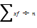
123650
Average mark of 50 students 24.72
- Pre, present &post conditions of all economic problems
Explain with example.
- Statistics- Singular noun.
Limitations
  - Study of numerical facts only
  - Study of aggregates only.
  - Any relevant answers.(ex)
- NSSO -sources of secondary data.
– Under MSPI.
–Regular sample surveys
-Parameters:
Census –under government of India.
-every 10 years last 2001.
-Parameters:
Systematic sampling:
Unit of population are numerically, geographically and alphabetically arranged.
Merits and demerits
(Any two)
Or
Basic | Primary data | Secondary data
origin | original | Already in existence
Cost | Expensive | Economical
Time | Consuming | Saving
Accuracy | More | less
Any relevant answers

  - Continuous series
  - 10
  - 5 students
  - 48 students

- 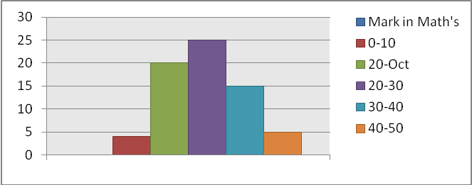
Table
Diagram
- 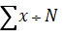
= 684÷15
= 45.6
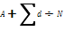
= 45.6
- Mark according to qualities of a questionnaire and types of questions.

Expenditure | No.of families
10-20 | 13
20-30 | 11
30-40 | 6
total | 30
6 families spend more than 30 a day.
8 families spend more than 15 a day.

- 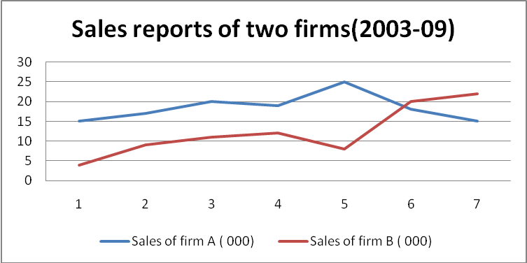

Items | % | Dg
Agriculture | 35 | 126
Irrigation | 20 | 72
Small scale industries | 25 | 90
Transport | 10 | 36
Others | 10 | 36

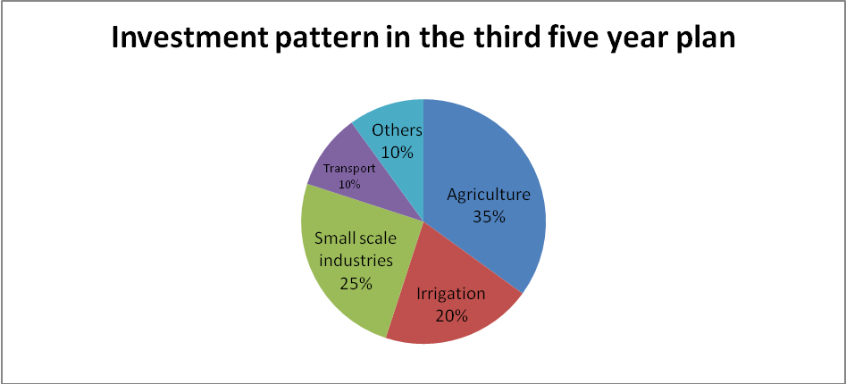
- 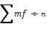
3850100
Average mark of 100 students 38.5
- ∑wx÷∑w
= 970÷16
= 60.625
Or
Merit
  - Simplicity
  - Stability
  - Accuracy test
  - Any relevant answers.(ex)
Demerits
- Unsuitability
- Misleading conclusions
- Effect of extreme items
- Any relevant answers.(ex)
Scope of averages in class room
- we can find average mark
- it help formulation of policies
- Find out average age, weight, height..Etc………
- Any relevant answers.(ex)
#############

Paper Submitted by:
MOHAMMED ASLAM (9685337106)
aslamelm@yahoo.com

