Topic: Matrices & Determinants
Q1. Construct 3x2 matrix If A = [a_{ij}], where a_{ij} = { i+j,if ij; i-j if i< j }
Q2. If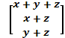 = find the values of x,y,z
Q3.A matrix of order 3 X 3 has a determinant 15. What is the value of |5A|?
Q4. If A= is a singular matrix, find x.
Q5. If A = , prove that (aI+bA)^{n} = a^{n} .I + na^{n-1} bA where I is a unit matrix of the order 2
And n is a positive integer.
Q6. If A=, then prove that A^{n} = , nN
Q7. Find x,y,z . If 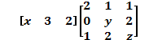=
Q8. If A=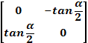, I is an identity matrix of order 2.
Show that : (I+A) = (I-A)
Q9. Show that A = satisfies the equation x² +4x-42 =0 . Hence find A⁻¹
Q10. If A = , find k so that A² =8A+KI.
Q11. Find value of x , If matrices A =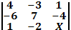 is not invertible.
Q12.If A= 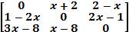 is a Skew Symmetric, find x.
Q13.If A= 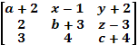 find a,b,c,x,y,z for which A is skew symmetric.

Q14.Without expanding show that 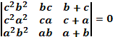
Q15. Using the properties of determinant , prove the following
- 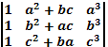 = (b-a)(b-c)(c-a)(a²+b²+c²)

- 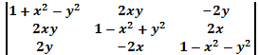 = ()³
- 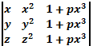= (1+pxyz)(x-y)(y-z)(z-x)

- 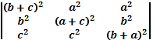 = 2abc(a+b+c)³

- 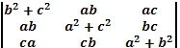 = 4

- 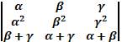 =

- 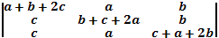 = 2(a+b+c)³

- 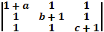 = abc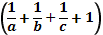= abc+bc+ca+ab.

Q16. Solve the system of equation by matrix method, where x0, y0, z0:
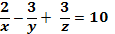 , 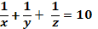 , 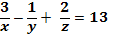 .
Q17. Solve the Equations by matrix method :2x-y+3z=5 , 3x+2y-z=7, 4x+5y-5z=9
Q18. Find the inverse of the 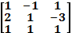 and hence solve the system of equations.
x +2y+z= 4 , -x+y+z= 0 , x- 3y+z = 2
Q19. Using elementary transformations, find the inverseof the matrix :