TOPIC:INVERSE TRIGONOMETRIC FUNCTIONS
Q1. Find the principal values of : (a) Sin⁻¹ (b) cos⁻¹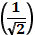
(c) tan⁻¹ - Sec⁻¹
Q2. Evaluate:
(a) cos⁻¹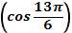 (b) cot⁻¹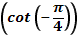
(c) cos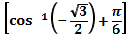 (d) tan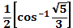
(e) sin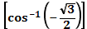
Short answer type Questions
Q3. Write the following functions into the simplest form :
- tan⁻¹ 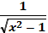 ,
- (b) tan⁻¹ 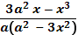 , a>0, 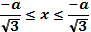

- (c) tan⁻¹ 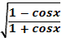, x<

- tan⁻¹ 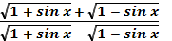, x.
Q4. Prove that the following:
- tan⁻¹x = 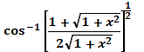
(b) tan⁻¹ 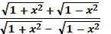= + .
(c ) cos [)}] = 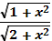 .
(d) 2 sin⁻¹ = tan⁻¹ .
- tan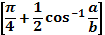+ tan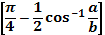= 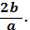
Q5. Show that :
- 2 tan⁻¹ + tan⁻¹ = tan⁻¹ .
- b) tan⁻¹ + tan⁻¹ + tan⁻¹ + tan⁻¹ = .
Q6. Show that :
- cos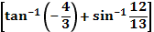= .
- b) +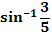 = 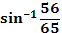
Q7. Solve for x: a) tan⁻¹ + tan⁻¹ 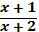 = .
b) tan⁻¹ + cot⁻¹ x =

