CONTINUITY & DIFFERENTIATION
Q1. Discuss the continuity of the following functions :
( a ) F(x) = 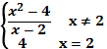 at x=2

( b ) 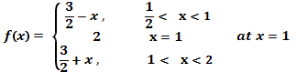
( c ) F(x) = 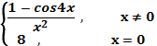 at x=0

( d ) 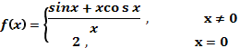 at x=0

Q2. For what k, are the following funcyions continuous at the indicated points :
( a ) F(x) = 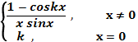 at x=0

( b ) F(x) = 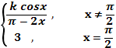 at x=

( c) 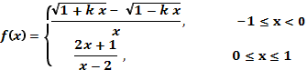 at x=0

(d) Exmamine the continuity 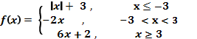

Q1. Differentiate w.r.t. x :
(a) sin² (b) 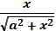
(c) sin²x . cos³x (d) cot
(e) (f)
(g) 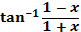 (h) 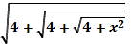

Q4. y = (x+ )^{n} Prove that : = 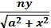

Q5. If y = 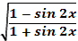 show that : + sec² { π/4 –x} = 0

Q6. Find for the following functions:
(i) sin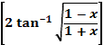 (ii) 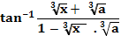
(iii) 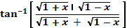
(iv) cos ⁻¹ ( 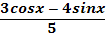)
(v) sin ⁻¹ (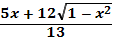) (vi) – }
(vii) if y= 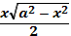 + , prove that =

(viii) If x= a(cos t +t sin t), y= b(sin t – t cos t). find ,
(ix.) find x^{y} + y^{x} = a^{b}

(x). If tan⁻¹(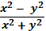) = a , then prove that =
(xi). If + 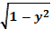 = a(x-y), prove that = 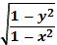.
(xii). Differentiate } w.r.t. 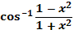
(xiii) If y= , then prove that : (1-x²)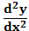-x -a²y=0
(xiv) If x +y = 0, prove that: = 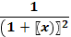
(xv) If x^{y} = , then prove that = 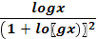
(xvi) If siny = x sin (a+y), prove that : = 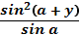
(xvii) If y +x = 1, prove that: =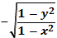
(xviii). find , y = x^{sinx} + (sin x )^{cosx}
Q7. If e^{y} + e^{x} = e^{x+y} , prove that = - e^{y-x}
Q8. If x^{p} y^{q} = (x+y)^{p+q} , prove that =
Q9. If x = 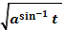, y = 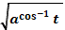 , prove that = -

